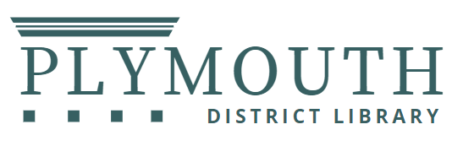

PUBLIC NOTICE
2026 Library Closure Dates

Thursday, January 1 | New Year's Day
Monday, February 16 | President's Day (Staff In-service Day)
Sunday, April 19 | Easter
Monday, May 25 | Memorial Day
Saturday, July 4 | Independence Day
Saturday, July 11 | Art in the Park
Sunday, July 12 | Art in the Park
Monday, September 7 | Labor Day
Saturday, September 12 | Fall Festival
Sunday, September 13 | Fall Festival
Wednesday, November 25 Thursday, November 26 | Closing Early at 6pm  Thanksgiving
Thursday, December 24 | Christmas Eve
Friday, December 25 | Christmas Day
Thursday, December 31 | New Year's Eve

