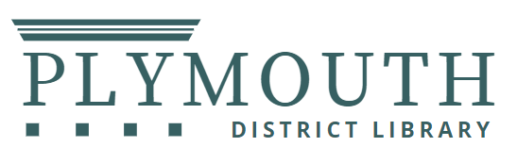

PUBLIC NOTICE
2026 Library Board Meeting Dates

Since 1989, Library Board meetings have been held on the third Tuesday each month. In 2026 the Board will meet at 7:00 p.m. on the following dates:

January 20 – ANNUAL MEETING
February 17
March 17
April 21
May 19
June 16
July 21
August 18
September 15
October 20
November 17
December 15

The District Library Board will provide auxiliary aids and services of materials being considered at the meeting, to individuals with disabilities upon reasonable notice. Individuals with disabilities requiring auxiliary aids or services should contact Shauna Anderson, Director, Plymouth District Library, 223 S. Main Street, Plymouth, MI at 734 453-0750 x 218

